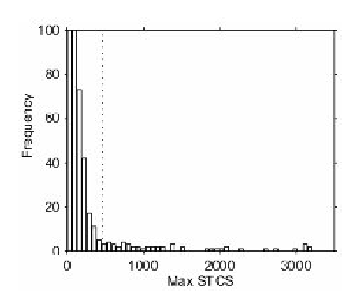
maximum suprathreshold cluster size
(with a primary threshold of 3)

fig 4
statistic of interest:
- voxel level statistic; generate statistic image
- maximal statistic; summarises statistic image in a single number

for T: max. STCS = 3101, only 5 relabellings of 999 yeald max STCS equal to or larger than 3101; p-value for experiment is thus 5/1000;
the 5% level is at 462 so any suprathreshold cluster with size greater than 462 voxels can be declared significant at 0.05
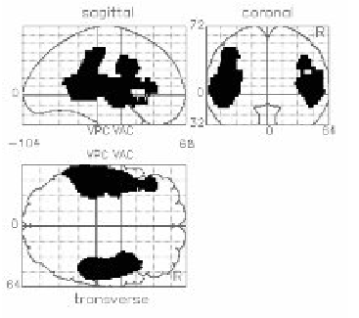
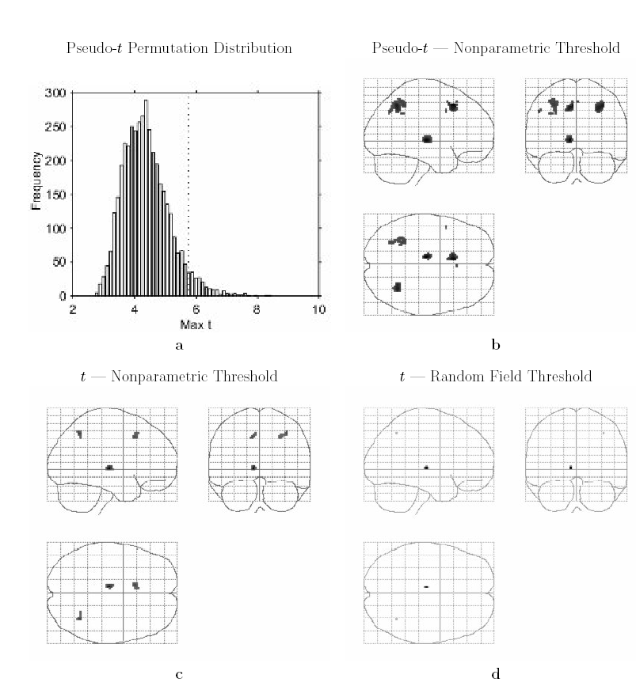

fig 7

